Project 6

Frederick Kelemen

2715308

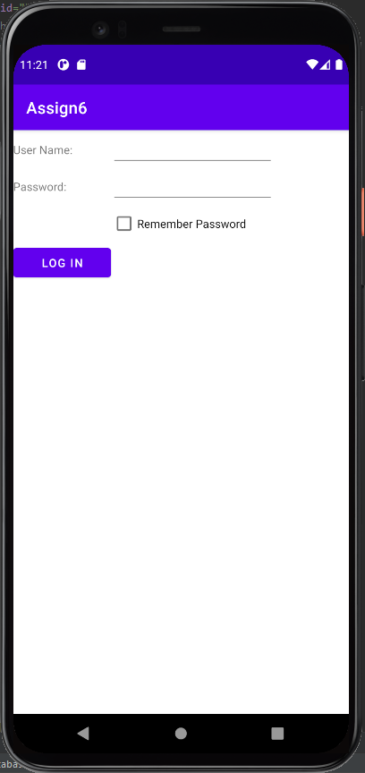Project 6 was used to display the TableLayout, the TableLayout allows the use of rows and columns I displayed this by making a username and password form in the TableLayout.